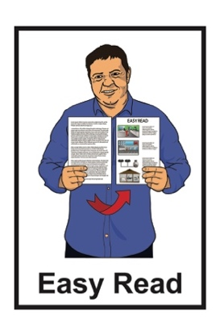

COVID-19:

Prepare and stay safe
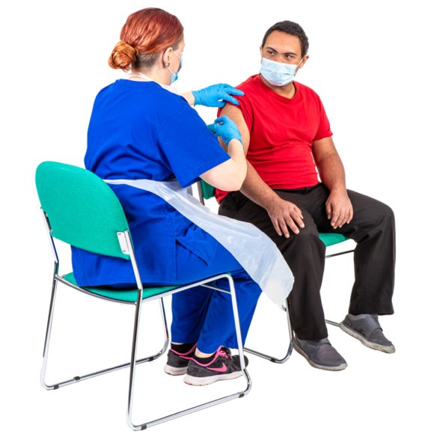

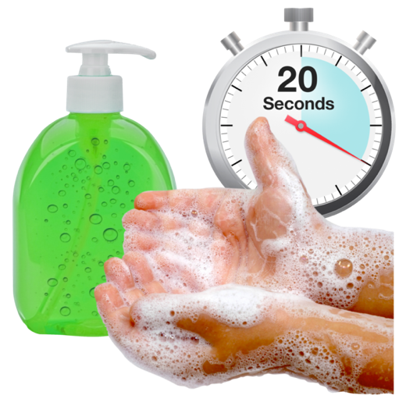
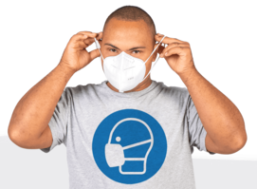

Updated: January 2024

Before you start

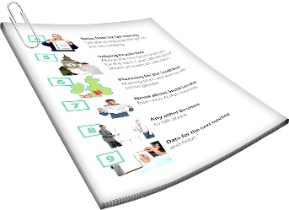
This is a long document.

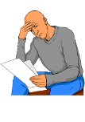
It can be hard for some people to read a document this long.

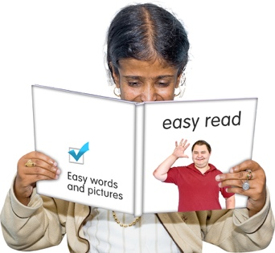
Some things you can do to make it easier are:
read it a few pages at a time
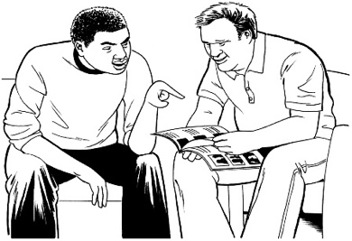
set aside some quiet time to look at it
have someone read it with you to support you to understand it.

What you will find in this document

Page number:
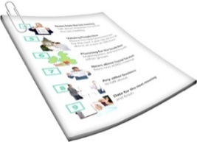

About this document 4
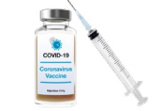

Vaccinations 6

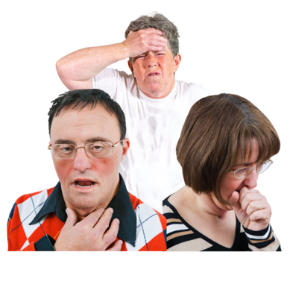
If you are unwell 10

Crowded places 17

Wearing a facemask 19

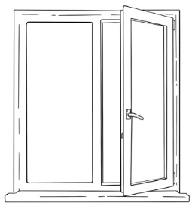
Ventilation 22

Page number:
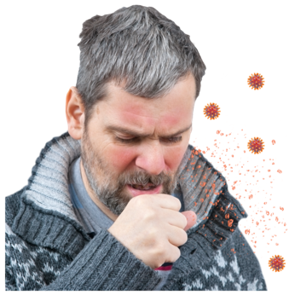

Coughs and sneezes 23

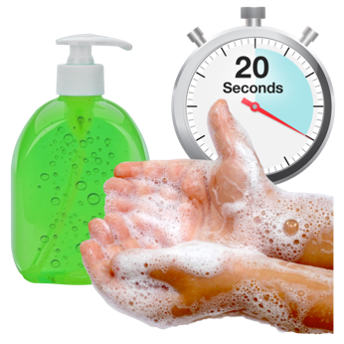
Keep your hands clean 25

Clean things people touch 28

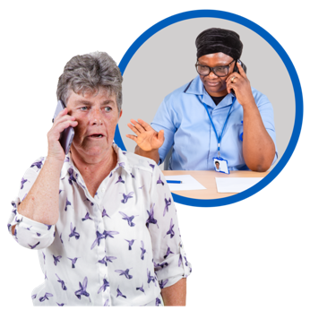
Where to get support 30

Where to find more information 32

About this document

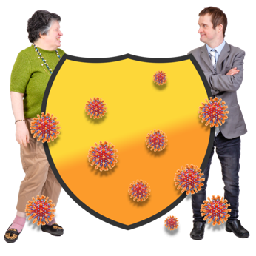
This document is about how to stay safe from COVID-19.

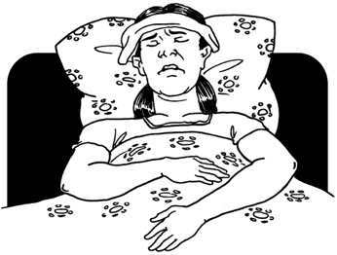

COVID-19 is a virus that can make people very ill.
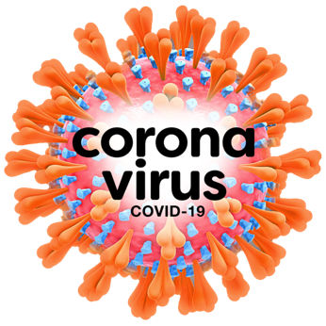

It is also called Coronavirus.

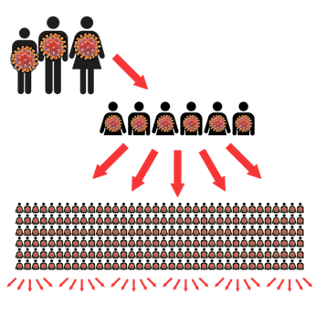
COVID-19 spreads between people very easily.

There is COVID-19 in the community.

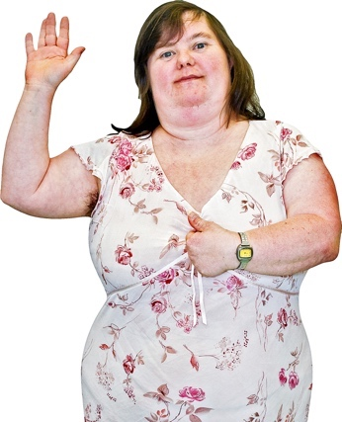
This document tells you some things you can do to take care of:
yourself
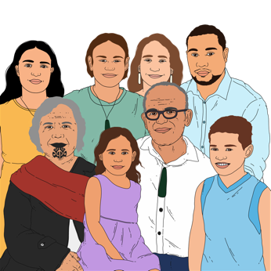
your whānau / family
your community.

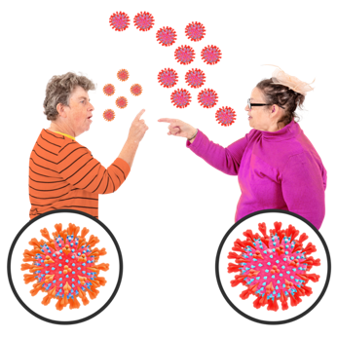
Some of these things make it harder to catch / spread COVID-19.

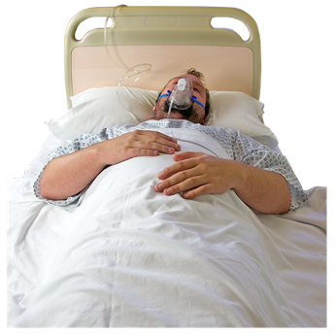
Some of these things mean there is less chance of getting very ill if you catch COVID-19.

Vaccinations

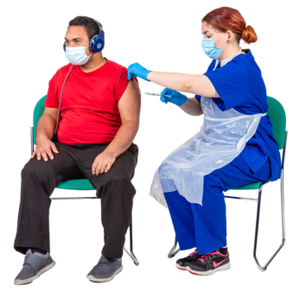
A vaccine is a medicine that can keep you safe from getting sick from a disease.

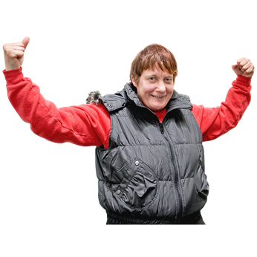
It works by helping your body make antibodies against the disease.

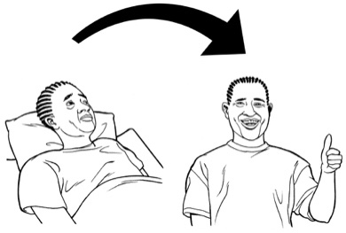
Antibodies help your body fight off illnesses.

The part of your body that makes antibodies is called your immune system.

Immunity means how well your immune system can fight off a disease / illness.
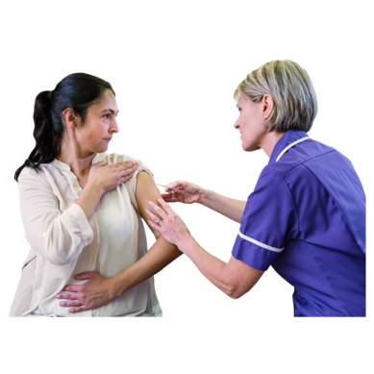
You can get immunity from COVID-19 by:
getting a COVID-19 vaccine
catching COVID-19.
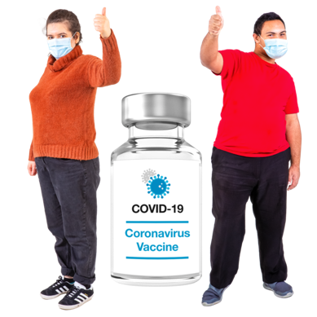

Getting a vaccine is a safer way to get immunity than catching COVID-19.
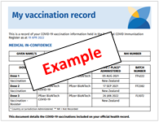

It is important to get all your COVID-19 vaccines.

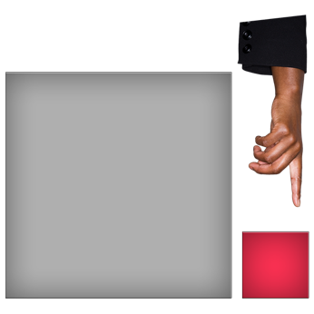
The immunity you get from a COVID-19 vaccine wears off over time.

You might be able to get a COVID-19 booster vaccine.

Getting a COVID-19 booster will give you more immunity again.

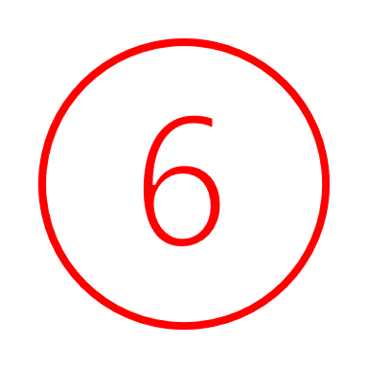
If you catch COVID-19 you may have to wait 6 months before you can get a COVID-19 vaccine.

Getting your COVID-19 vaccines means that if you catch COVID-19 you have less chance of:
being very unwell
needing to go to hospital.

Getting a COVID-19 vaccine also means you have less chance of giving COVID-19 to other people including:
people who might get very unwell with COVID-19
people who cannot get a COVID-19 vaccine.

If you are unwell

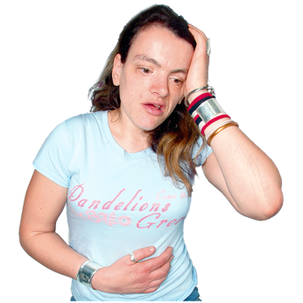
If you are unwell you should stay at home until you feel well again.

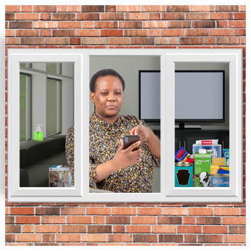
Staying home when you are unwell means there is less chance of giving COVID-19 to other people.

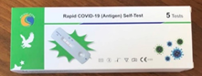
You should do a COVID-19 test if you have symptoms of:
COVID-19
a cold
the flu.
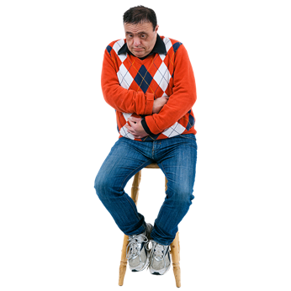

Symptoms means signs that you may have an illness.
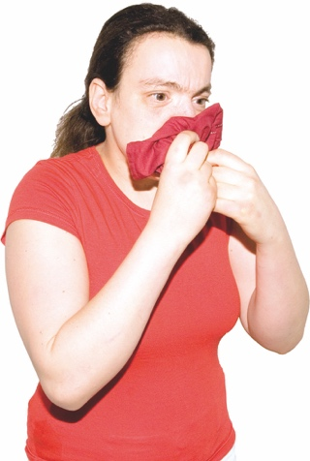
COVID-19 symptoms include things like:
a cough
sneezing and a runny nose
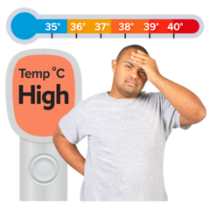
finding it hard to breathe
high temperature of at least 38°C on a thermometer – this is when you would feel very hot
a sore throat
not being able to smell things for a little while
headache.

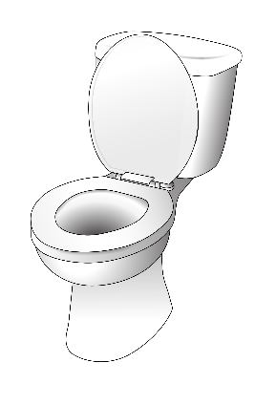
Other symptoms of COVID-19 include:
diarrhoea / runny poo
nausea / vomiting
muscle pain or body aches
malaise — a general feeling of being unwell.

All these symptoms:
do not always mean you have COVID-19
can be symptoms of other illnesses like a cold or flu.

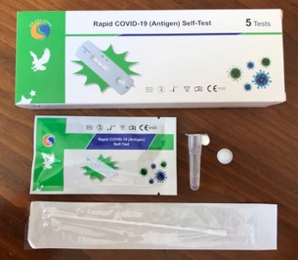
Most COVID-19 tests are RATs.

A RAT is a COVID-19 test you can do at home.

RATs are also called rapid antigen tests.
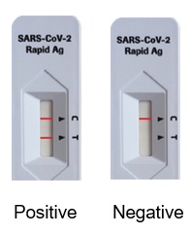

If the test is positive that means you have COVID-19.

If the test is negative that means you may not have COVID-19.

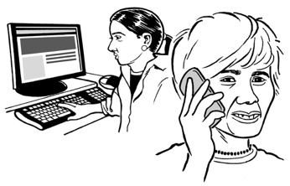
After you do a RAT you should report the result.

You can report your RAT result on the My COVID Record website at:

https://mycovidrecord.health.nz

My Covid Record is not in Easy Read.

You can also report a RAT result over the phone on:

0800 222 487

If your RAT is positive you should isolate for 5 days.

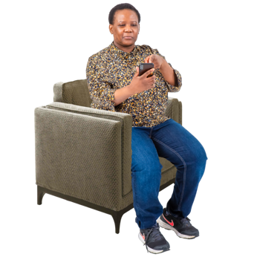
Isolate means you:
stay at home
keep away from other people.

Isolating stops COVID-19 speading to other people.

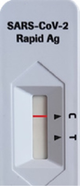
If your RAT is negative you should still stay at home until you feel well again.

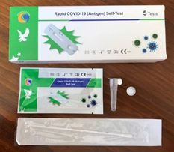
You should do a RAT before you visit people who might get very unwell with COVID-19 like:
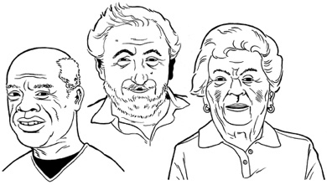
older people
people who have medical conditions that make it hard for them to fight off diseases.
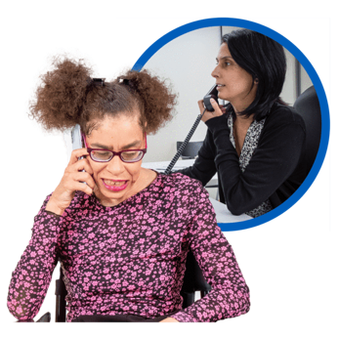

You can get more information about what to do if you are unwell from your doctor.

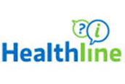
You can also call Healthline on:

0800 358 5453

Crowded places

COVID-19 spreads very easily when there are a lot of people in one place like:
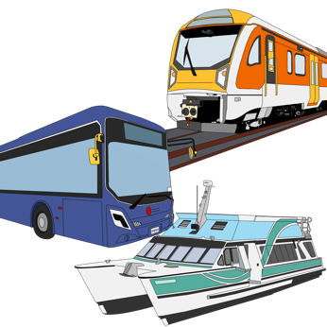
buses
trains
shops.

You have more chance of catching COVID-19 in indoor places where there is not a lot of ventilation.
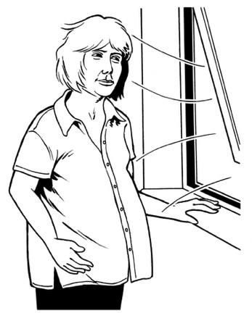

Ventilation means fresh air that moves around indoors.

COVID-19 spreads when people do things like:
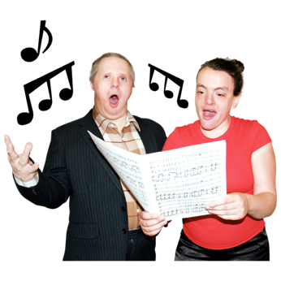
talk
shout
sing.

You can lower your chance of catching COVID-19 by:
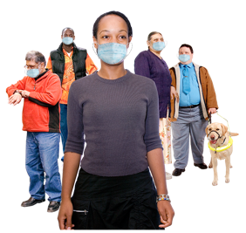
staying away from crowded places when you can
wearing a face mask in crowded places.

Wearing a face mask

Wearing a face mask means you have less chance of catching COVID-19.

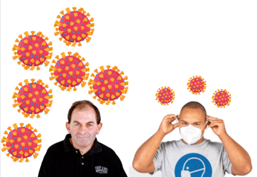
Face masks can also stop you from giving COVID-19 to other people.

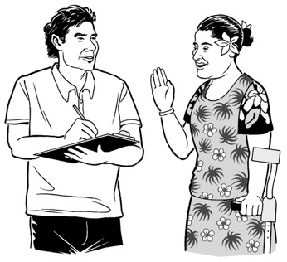
Face masks can stop particles from going into the air when you:
talk
laugh
cough
sneeze.

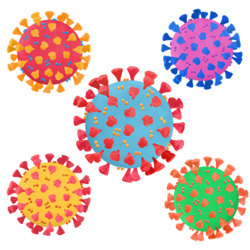
Particle means a very small piece of something like:
water
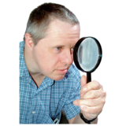
dust.

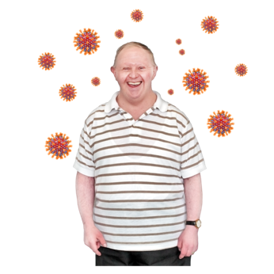
Particles are often so small we cannot see them with our eyes.

Particles with COVID-19 on them can float in the air for a long time.
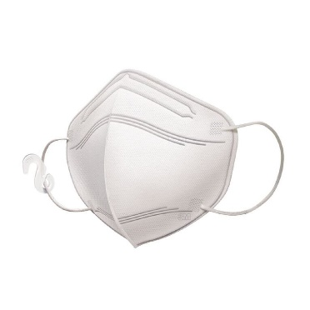

Respirator masks can stop you from breathing in COVID-19 particles.

Respirator masks are a kind of face mask that you throw out after you have used them.

Respirator masks fit closer to your face than other types of mask.

Respirator masks are also called:
N95
KN94
FFP2.

Face masks should fit your face well without any gaps.
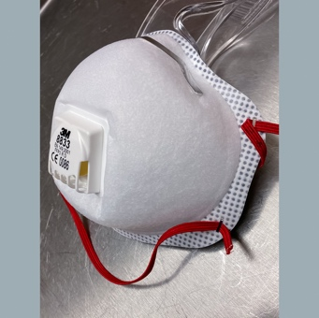

You should choose a face mask that does not have a vent to let air out.

Ventilation

Good ventilation means COVID-19 particles will not stay in the air for as long.

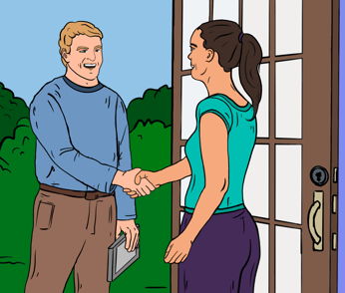
It is a good idea to let fresh air in when you have visitors to your:
home
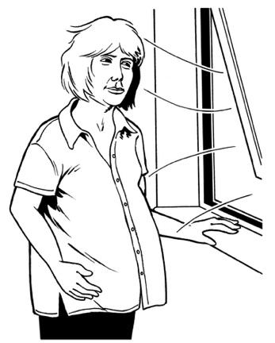
work.

You can let fresh air in by having a window open a little bit all day.

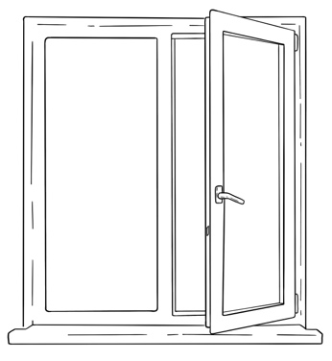
You can also open your windows right up for 15 minutes a few times a day.

Coughs and sneezes

Coughing / sneezing can spray a lot of COVID-19 particles into the air.

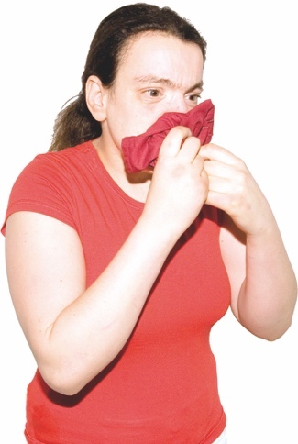
When you cough / sneeze you can stop COVID-19 from spreading by covering your:
nose
mouth.

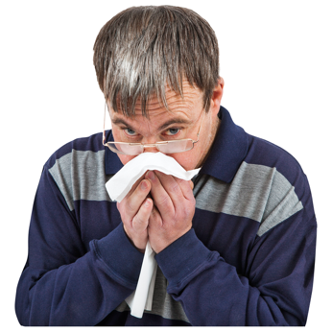
Cover coughs / sneezes with:
your elbow
a tissue.

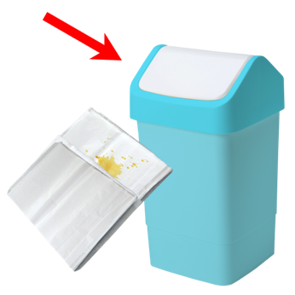
You need to put used tissues into the rubbish straight away.

Remember to wash your hands after you cough / sneeze.

Keep your hands clean

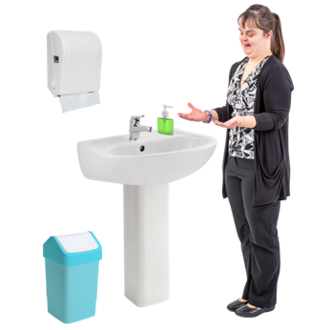
Washing your hands can stop diseases like COVID-19 from spreading.

You should wash your hands after:
being somewhere where there are a lot of people
coughing
sneezing
blowing your nose
using the toilet.
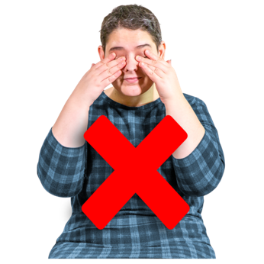

Do not touch your face if your hands are not clean.
You need to wash your hands for 20 seconds using:
soap
water.

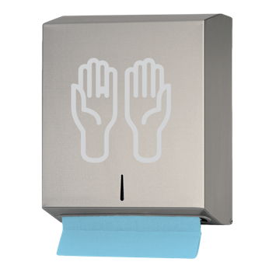
After you wash your hands you should dry them well.

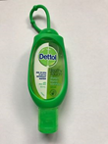
You can also clean your hands with a hand sanitiser that has alcohol in it.

Make sure you use enough hand sanitiser to cover both your hands.
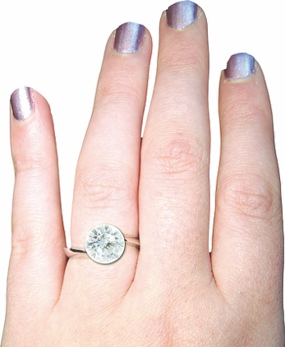

Rub the sanitiser all over your hands until they are dry.

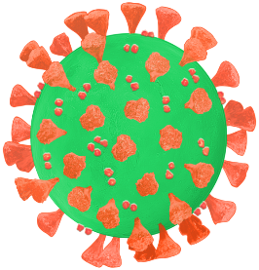
Cleaning your hands will kill the COVID-19 germs.

It will also kill other germs that can make you unwell.

Having clean hands is very important if you visit someone who could get very unwell from COVID-19.

Clean things people touch

COVID-19 particles can go into the air when someone:
breathes
talks
coughs
sneezes.

Some particles can fall down onto surfaces like:
tables
benches / counters.

It is important to clean the surfaces in your home often.

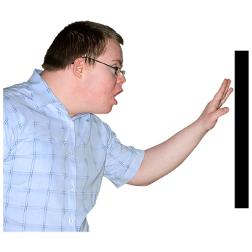
It is also important to clean the things people touch often like:
door handles
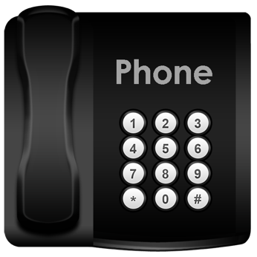
light switches
phones.

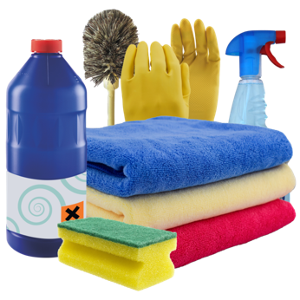
You can use regular cleaning products.

Follow the instructions on the bottle / container.

Remember to store cleaning products safely.

Where to get support

You can phone the COVID-19 disability helpline to get information about:
COVID-19 tests
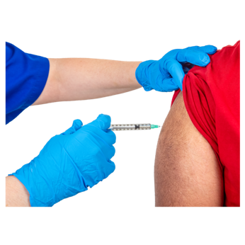
masks
COVID-19 vaccines
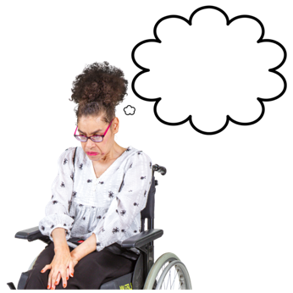
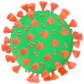
how to look after yourself when you have COVID-19
any other worries you have about COVID-19.

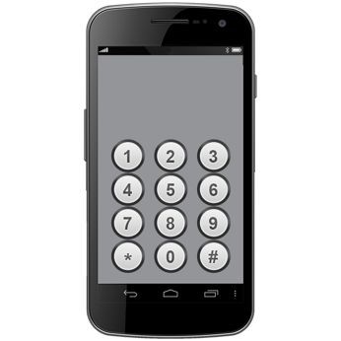
The phone number for the COVID-19 disability helpline is:

0800 11 12 13

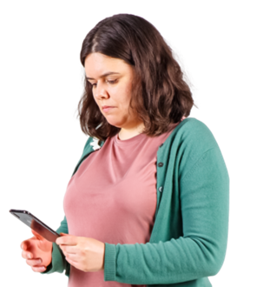
You can also text the COVID-19 disability helpline on:

8988

You can also call Healthline on:

0800 358 5453
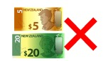

It does not cost money to call these numbers.

Where to find more information

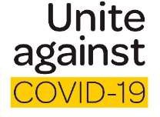
The government website about COVID-19 is:

https://covid19.govt.nz

You can use this website to find out more information about:
looking after yourself if you have COVID-19
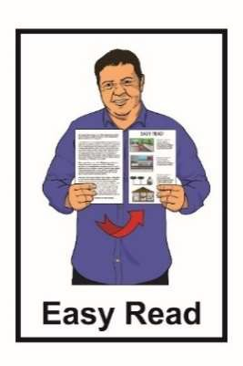
where to get support if you need it.

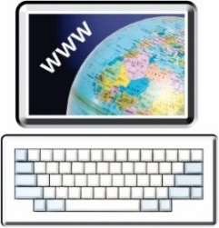
More information about COVID-19 is available in Easy Read on the COVID-19 website at:

https://covid19.govt.nz/easy-read/
This information has been written by
Te Whatu Ora Health New Zealand.

It has been translated into Easy Read by the Make it Easy Kia Māmā Mai service of People First New Zealand Ngā Tāngata Tuatahi.

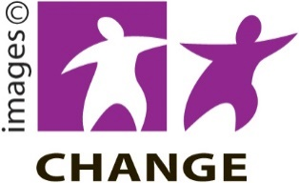
The ideas in this document are not the ideas of People First New Zealand Ngā Tāngata Tuatahi.

Make it Easy uses images from:

- Changepeople.org

- Photosymbols.com

- SGC Image Works

- Huriana Kopeke-Te Aho
- T.Wood.
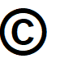
All images used in this Easy Read document are subject to copyright rules and cannot be used without permission.

